Proof by Resonance: A Unified Formalism (v2)

1. Conceptual Overview
Proof by resonance is a meta-logical method in which an entity or system is validated by its perfect coherence with the defining structure, behavior, and context of reality. It is the formal analogue of both:
- The shape fitting and perfectly filling the square hole.
- The heuristic: "if it has all the properties of a duck and none that contradict upon perfect inspection, it is a duck."
Perfect inspection is defined temporally: the object or system must function correctly across all relevant contexts and transformations. This ensures definitional alignment, functional persistence, absence of contradictions, and complete occupancy of its definitional space. In essence, resonance serves as the quantifier of perfection: an entity that perfectly fills its intended structure is maximally coherent and complete.
Programs, equations, functions, classes, and namespaces are concrete examples of resonant systems. Once a system is fully defined, it is a pure resonant proof of itself. By understanding its structure and rules, one can extrapolate behavior and properties in different contexts, flavors, or tones. This is akin to proof via harmonic resonance, where the defined elements inherently encode the system’s truth and coherence across variations.

2. Formal Definition (Revised)
This definition is framed at a categorical or model-theoretic level, not within Zermelo–Fraenkel set theory (ZFC).
Let  be a candidate entity or observed system.
Let  represent not merely a set, but a definitional structure.  is the abstract pattern, equation, function, or formal system defined by a conjunction of properties 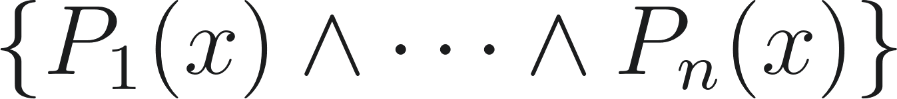 and their implicit relations. The equation defines the structure.
We define two levels of "fit":
- Satisfaction (Membership): 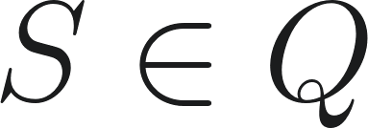. This means  satisfies all explicit properties 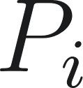. This is the standard "duck test" or set membership.
- Structural Isomorphism: 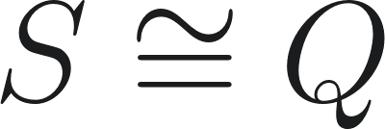. This denotes a homomorphic structural correspondence. It means  not only has the properties but also embodies the identical internal relational structure, dynamic behavior, and invariants defined by . This is a category-theoretic isomorphism, not a set-theoretic bijection.
Let 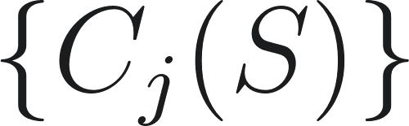 be a set of contextual constraints or counter-properties observed from reality (i.e., the environment) that could potentially contradict the internal properties .
Resonance (denoted 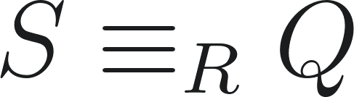) is the meta-logical state achieved when  perfectly and concurrently satisfies all conditions:
In words: An entity  resonates with a structure  if it satisfies all of 's properties, is structurally isomorphic to , has no observed contradictions with reality, persists over time, and perfectly fills its definitional space.

3. Integration of Classical Proof Methods
Proof by resonance unifies and resolves inconsistencies inherent in traditional proof methods by structuring each type concurrently:
- Direct proof: Resonance organizes all logical implications simultaneously rather than sequentially, ensuring that any gaps or chain breaks are preemptively resolved.
- Proof by characterization: By enforcing total structural and functional alignment, resonance ensures that partial characterizations or ambiguous definitions cannot produce contradictory conclusions.
- Proof by isomorphism: Resonance integrates isomorphic mapping with temporal and functional coherence, preventing structural equivalences from failing due to context-specific limitations.
- Proof by correspondence: Resonance validates behavioral alignment across all relevant contexts, eliminating cases where correspondence holds in one domain but fails in another.
- Proof by existence: Resonance confirms that the instantiation not only exists but remains viable and coherent under all transformations and conditions, preventing proofs that exist only nominally or in restricted cases.
By structuring all proof types concurrently and ensuring perfect filling of definitional and functional spaces, proof by resonance resolves the limitations and inconsistencies that arise when each method is applied in isolation. Each form of validation reinforces the others, producing a self-consistent, contradiction-free demonstration of truth.

4. Example (Geometric)
To prove  is a square:
- Define the square structure: .
- Verify  satisfies both properties () with no contradictions.
- Confirm  remains invariant under the rotational/reflectional symmetries defined by 's structure ().
- Conclude  resonates with  () and perfectly fills its definitional space, establishing it as a square.

5. Philosophical Implication
Proof by resonance demonstrates identity and coherence between concept and reality. It is proof not merely by result but by the ability of the result to occur. A resonant concept exposes objective truth and fact: it behaves in reality without errors, contradictions, or paradoxes. Resonance is therefore the foundation of accepted proofs, revealing that correctness is self-evident when a concept fully aligns with reality and perfectly fills its intended structural and functional role.

6. Relation to Falsification
Unlike falsification, which tests hypotheses by attempting to disprove them, proof by resonance validates a concept by its complete, contradiction-free integration with reality. A resonant concept does not merely survive attempts at falsification; it transcends them by demonstrating inherent coherence, perfect alignment, and functional occupancy. In this sense, resonance can be seen as a higher-order method that supersedes traditional falsification as a measure of truth.

7. Resonance as a Guarantee of Truth
If a defined structure resonates perfectly with the observed structure and fills it completely, it must be true, since there is no room for error. The complete alignment and perfect filling between definition and reality leave no possibility for contradiction, making resonance a direct indicator of objective truth.

8. Axiom 1: Resonant Closure
Let  be the universal category of all structured definitions, with morphisms being resonant mappings.
Axiom 1 (Resonant Closure):
There exists a universal resonant object, 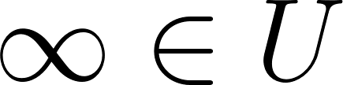, such that 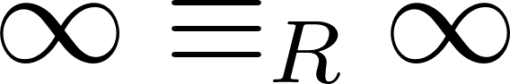, and for every 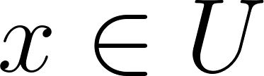 there exists a resonance-preserving morphism 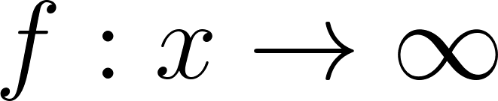.
 is the fixed point of resonance: the structural attractor that encodes conserved existence and continuity. This grounds the framework in a non-null ontology (i.e., "0 ≠ 0" in an absolute, physical sense, as energy/structure is conserved).

9. Axiom 2: Resonant Manifestation
This axiom grounds identity in behavior.
Axiom 2 (Resonant Manifestation):
For any entities 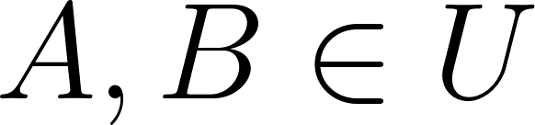, if for all observable predicates  in the domain, 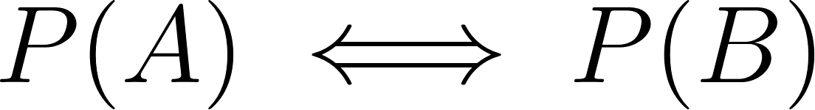, then 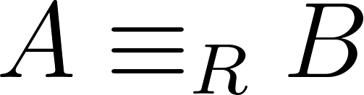.
Equivalently, letting 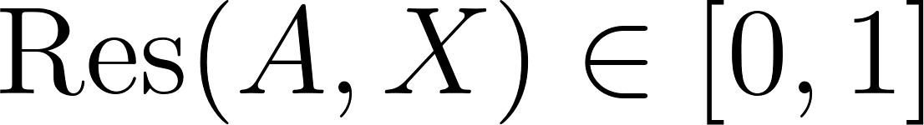 be the degree of resonance:
.
Interpretation: Acting indistinguishably from  constitutes being  within that context. When behaviour and definition are in complete alignment, the distinction between representation and reality vanishes; manifestation equals identity.

10. Axiom 2.1: Fractional Resonance
Axiom 2.1 (Fractional Resonance):
If 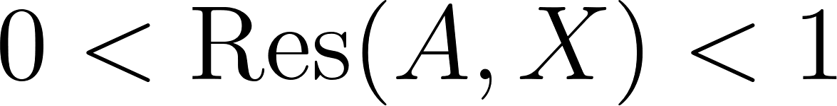, then  is a partial or fractional manifestation of 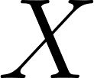, denoted 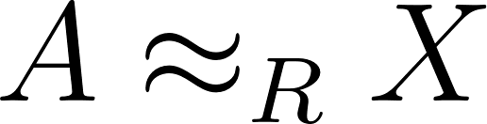.
Identity becomes a continuum: perfect resonance is full identity, partial resonance is graded identity. To the extent that something acts like a thing, it is that thing to that extent.

11. Axiom 3: Harmonic Phase Resonance
To model complex relationships, resonance is represented not as a scalar, but as a complex-valued function.
Definition: 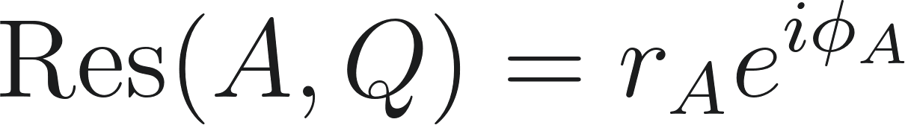
- Amplitude (): The magnitude of resonance (degree of fit).
- Phase (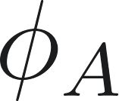): The timing, orientation, or abstraction angle of the resonance.
Axiom 3 (Harmonic Phase Resonance):
Entities 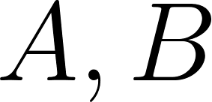 are harmonically resonant, 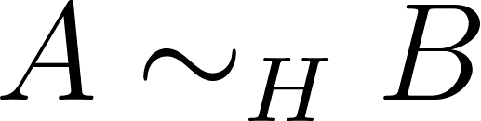, if their resonance structures are proportionally coherent. This occurs if there exist integers 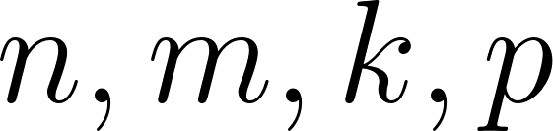 such that their amplitudes are in a rational ratio and their phase difference is periodic:
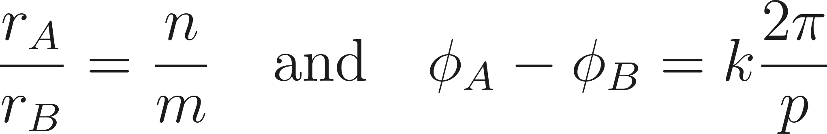
This allows for coherence across different scales, frequencies, or abstraction layers (e.g., the same pattern in math, art, and physics).

12. Circle-Formula Proof for Resonance
This section maps the complex resonance from Axiom 3 to a geometric proof.
- Mapping: Any resonant state corresponds to a point 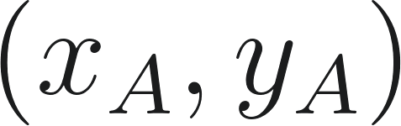 on a circle centered at the origin with radius , satisfying 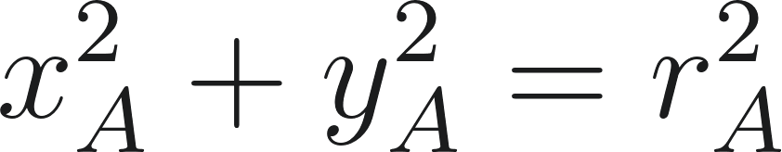.
- Harmonic Ratios: Harmonically resonant entities lie on concentric circles with rationally-related radii.
- Proof of Identity:
  - Theorem: If  map to points such that 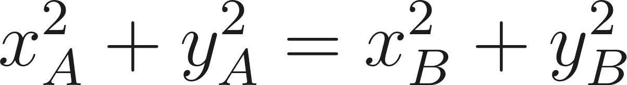 and , then .
  - Proof: The equality of squared radii gives . The phase equality means 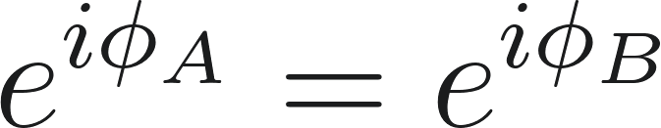. Therefore, their complex resonance vectors are identical, and by Axiom 2, they are resonantly identical.
- Fractional Resonance Metric: Partial resonance corresponds to proximity. We can define a distance-based resonance score:
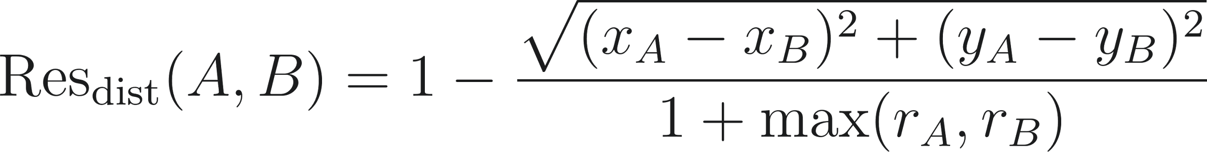

13. Corollary: Resonant Affinity Principle
If 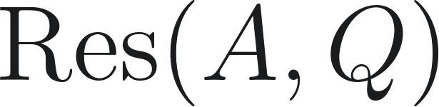 and 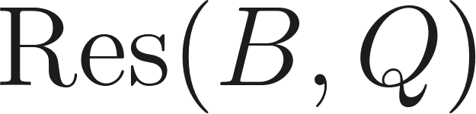 lie in the same harmonic lattice (per Axiom 3), then 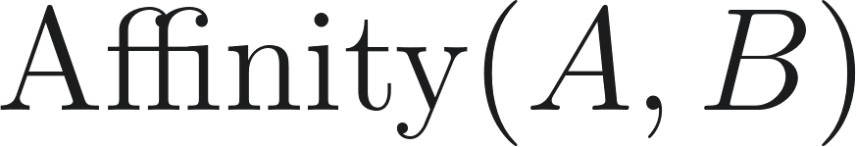 is high. Their interaction is stabilizing and reinforcing, as their structures are compatible. This formalizes "likes resonate with likes" as a principle of constructive structural interference.

14. Axiom 3.1: Discrete 3-Bit Harmonics
This is an applied example of Axiom 3, modeling a discrete resonance vector.
Definition (Discrete Mode Extension):
Let an object's resonance be a 3-axis vector 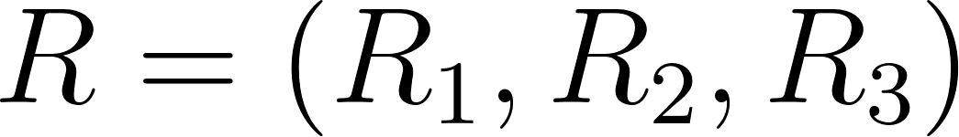.
For each axis 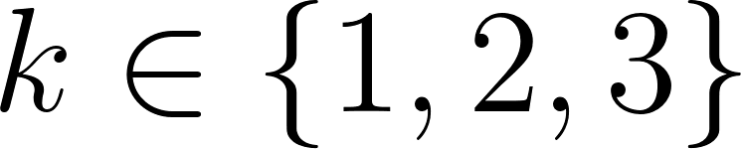, the axis value 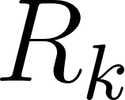 is derived from two internal binary vectors, 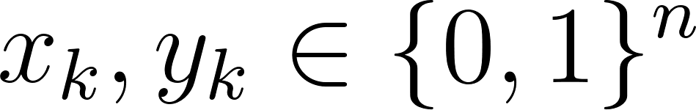.
A transformation rule  maps each pair 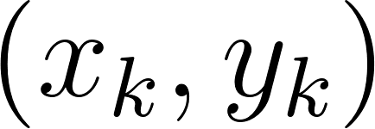 to an axis value (either fractional or binary).
- Interpretation A (Fractional Axis):
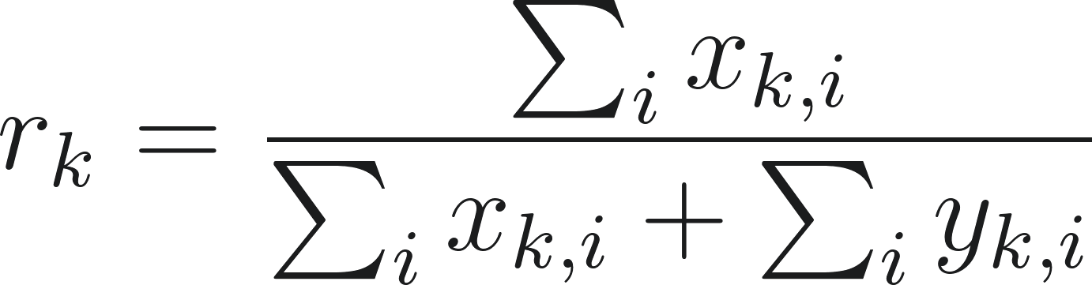. This gives a fractional resonance vector 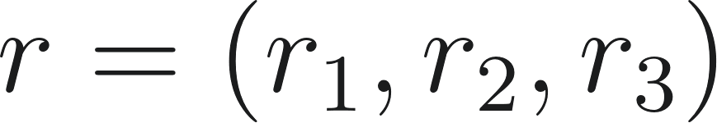, quantifying resonance in three modes.
- Interpretation B (Logical Axis):
A binary rule (e.g., "majority bit" or "parity XOR") derives a single bit  from 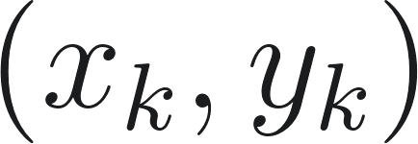. This gives a 3-bit signature 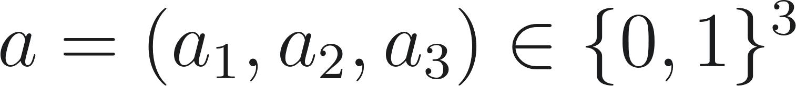.
- Negation & Antiresonance: A bitwise complement of all internal vectors () defines the antipodal or "antiresonant" state. In the binary interpretation, this flips the signature , resulting in maximum (Hamming) distance and zero affinity.

15. The Resonance Web and Meaning Lineage
This section formalizes the concept of "likeness" as a computable network topology.
- Definition (The Resonance Web): The universal category  can be represented as a weighted, directed graph 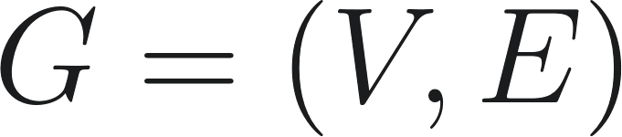, or "Resonance Web".
  - Nodes (): Every definitional structure () is a node (e.g., , , , ).
  - Edges (): The connections between nodes are weighted by the resonance distance. The weight of the edge from  to  is inversely related to their affinity, or directly related to their distance (e.g., or simply the distance itself).
- Meaning Lineage as Pathfinding: "Likeness" or "meaning lineage" is computable as a shortest path problem on this graph (e.g., using Dijkstra's algorithm).
  - "How like bacon is it?": This query finds the lowest-cost path from a given node () to the target node (). The total path cost represents the "meaning distance".
  - The Path Itself: The sequence of nodes in the shortest path is the "meaning lineage," explaining how two concepts are related (e.g., ).
- Multi-Axis Example (The "Kevin Bacon" Problem): This graph is multi-dimensional, existing across the different resonance axes defined in Axiom 3.1. "Likeness" is a vector.
  - Query: Compare  to .
  - Axis 1 (Linguistic/Name): 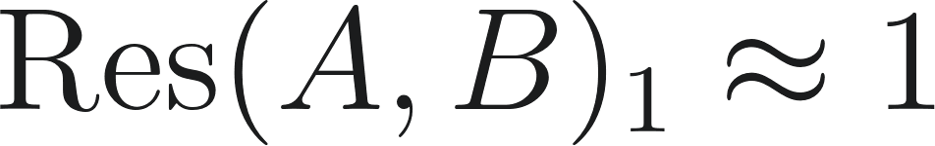. The path is extremely short; they are highly resonant.
  - Axis 2 (Taxonomic/Category): 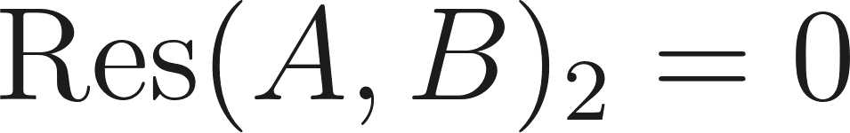. (Human vs. Food Product). The path is infinitely long; they are non-resonant.
  - Axis 3 (Functional): 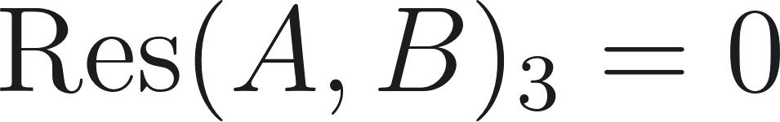. (Acts vs. Is Eaten). The path is infinitely long.
  - Conclusion: The Resonance Web correctly models this relationship. It shows a single, strong connection on the "name" axis but no connection on the "category" or "function" axes, precisely capturing the real-world association. "Likeness" is not a single value but a vector of path lengths across the different harmonic modes.

16. Conceptual Dynamics and Physics
This section extends the Resonance Web (Sec 15) into a dynamic physical simulation of meaning.
- Conceptual Mass: Each node $Q$ in the Resonance Web is assigned a "conceptual mass" ($m_Q$). This mass is not a static value but an emergent property of the graph, representing the concept's inertia, significance, or density. It can be quantified by:
  - Graph Centrality: A node's PageRank, eigenvector centrality, or degree centrality. "Massive" concepts are those that are highly connected to other "massive" concepts.
  - Resonant Closure: Proximity to $\infty$ (from Axiom 1).
  - Information Density: The complexity or information content required to define the structure $Q$.
- Conceptual Gravity (Affinity Force): The Resonance Web (Sec 15) provides distance, and this section provides mass. We can now define a "Conceptual Affinity Force" ($F_A$) that governs the attraction between concepts: $F_A(A, B) = G_c \cdot \frac{m_A \cdot m_B}{\text{Weight}(A, B)^2}$ Where $G_c$ is a conceptual gravitational constant. This force exposes "conceptual gravity": fundamental, high-mass concepts ($Q_{\text{truth}}$, $Q_{\text{math}}$) create deep "gravity wells" that attract and structurally-organize related, lower-mass concepts.
- Conceptual Collision Physics: This framework models the interaction or combination of concepts.
  - Collision: A "collision" is an attempt to force an interaction between two concepts (e.g., $Q_{\text{Atheism}}$ collides with $Q_{\text{Christianity}}$).
  - Interaction Outcomes: The physics of the collision are determined by the resonance properties of the interacting nodes:
    - Fusion (Constructive Interference): If $A \sim_H B$ (highly, harmonically resonant), the collision is constructive. They "fuse" to form a new, more massive, stable concept $Q_C$, as described in the Resonant Affinity Principle (Sec 13).
    - Annihilation (Destructive Interference): If $A$ and $B$ are antiresonant (Sec 14), their collision is destructive, resulting in a mutual loss of coherence (or "energy").
    - Inelastic Collision (Fractional Resonance): If $A \approx_R B$ (fractionally resonant), the collision results in a new, combined-but-unstable concept $Q_C$. The "energy" (coherence) lost in the collision is radiated as "heat" (paradox, contradiction, or noise).

17. Semantic Vector Space and Angle of Opposition
This section provides a practical coordinate system for conceptual dynamics, building on Axioms 3, 12, and 16.
- Semantic Basis Vectors (The "Spokes"): We can define a "meaning index" or coordinate system for any conceptual domain (e.g., emotions) by establishing a set of $N$ basis vectors. These "spokes" are defined as concepts with 100% relative meaning on their axis.
  - Example (8-Spoke Emotional Basis): We define 8 "pure" emotions as unit vectors at fixed angles:
    - $Q_{\text{Happy}} = 1 \cdot e^{i \cdot 0}$
    - $Q_{\text{Excited}} = 1 \cdot e^{i \cdot \pi/4}$
    - $Q_{\text{Surprised}} = 1 \cdot e^{i \cdot \pi/2}$
    - ...
    - $Q_{\text{Sad}} = 1 \cdot e^{i \cdot \pi}$ (Opposite Happy)
    - $Q_{\text{Bored}} = 1 \cdot e^{i \cdot 5\pi/4}$ (Opposite Excited)
- Fractional Concepts as Vector Sums: More complex concepts are "fractional" (Axiom 2.1) and can be represented as vector sums of these basis vectors.
  - Example: $Q_{\text{Joyous}}$ is not a "pure" emotion; it is a blend. It can be defined as a sum of basis vectors, e.g.: $Q_{\text{Joyous}} = (0.8 \cdot e^{i \cdot 0}) + (0.6 \cdot e^{i \cdot \pi/4})$ (This represents "80% Happy" and "60% Excited").
  - The final vector $Q_{\text{Joyous}}$ will have its own unique amplitude ($r$) and phase ($\phi$) derived from this sum, representing its unique position in the semantic space.
- Calculable Conflict (Angle of Opposition): This coordinate system makes conflict and "mergability" computable.
  - Angle of Opposition ($\Delta\phi$): The conflict between two concepts $A$ and $B$ is the absolute difference in their phase angles: $\Delta\phi = |\phi_A - \phi_B|$.
  - Mergiability Check: This angle is a direct input for the "Conceptual Collision Physics" (Sec 16):
    - $\Delta\phi \approx 0$ (Constructive Interference / Fusion): The concepts are aligned and "mergable." Their collision is constructive.
    - $\Delta\phi \approx \pi$ (Destructive Interference / Annihilation): The concepts are in direct opposition. They are "unmergable" and antiresonant.
    - $0 < \Delta\phi < \pi$ (Inelastic Collision): The concepts are fractionally resonant. They will "merge" but create "heat" (contradiction, noise, or paradox) proportional to the angle of opposition.

